This document contains
Section1: pictorial
Section2: summary of projects undertaken

1.Pictorial portfolio
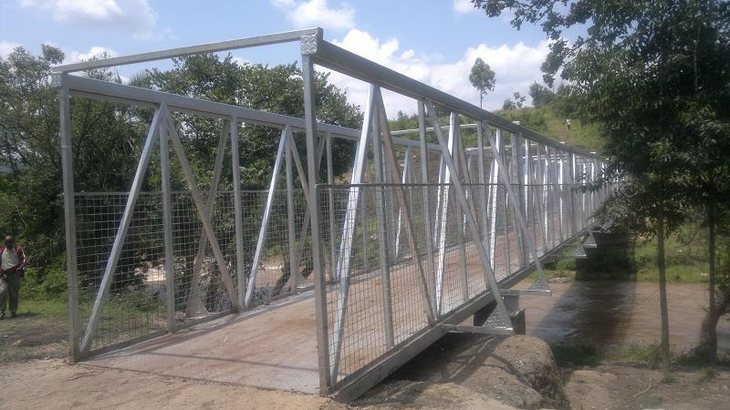
Sugoi Footbridge

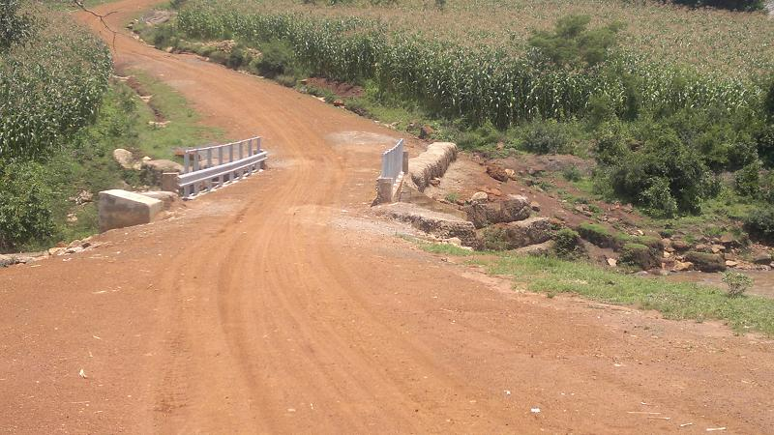
Tapsagoi-Moror-Ngenyilel Road

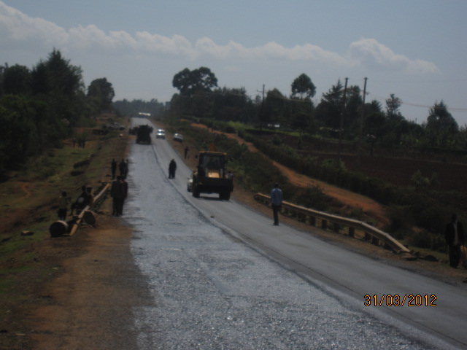
KITALE-SIBANGA ROAD PROJECT-Priming with MC-30

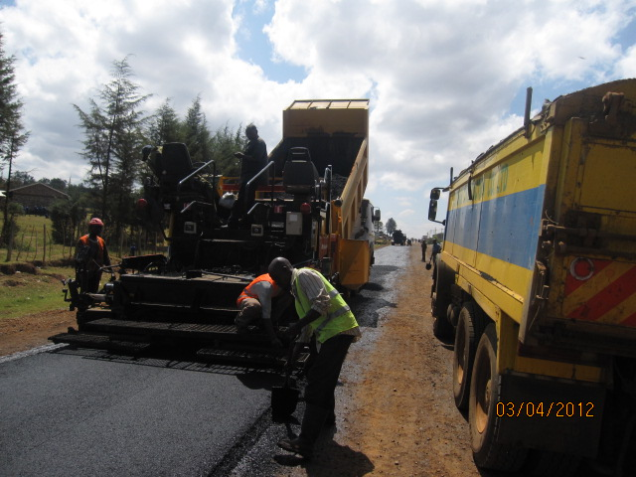
KITALE SIBANGA ROAD PROJECT-AC Laying

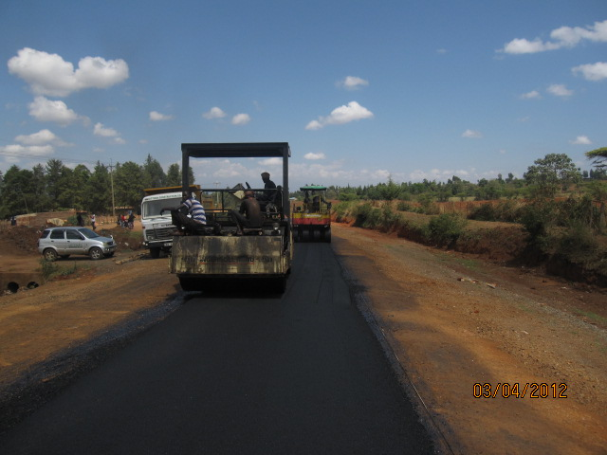
KITALE-SIBANGA ROAD- AC Laying

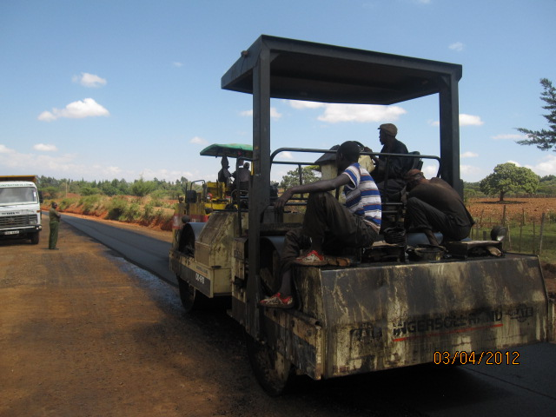
KITALE-SIBANGA- AC Laying

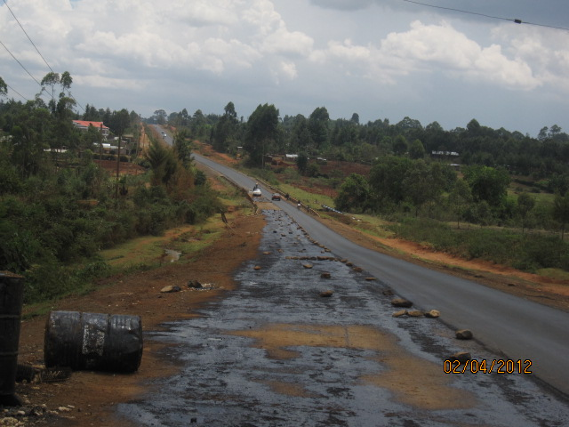
KITALE-SIBANGA-Priming with MC-30

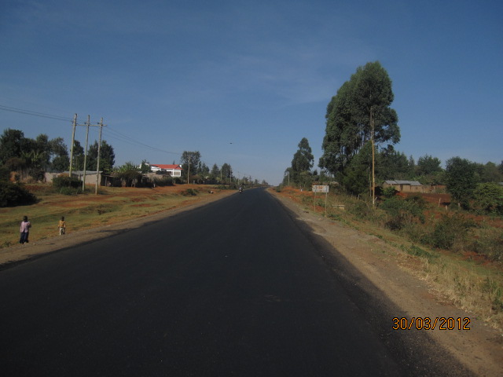
Kitale-Sibanga Complete Section of asphalt paved Road

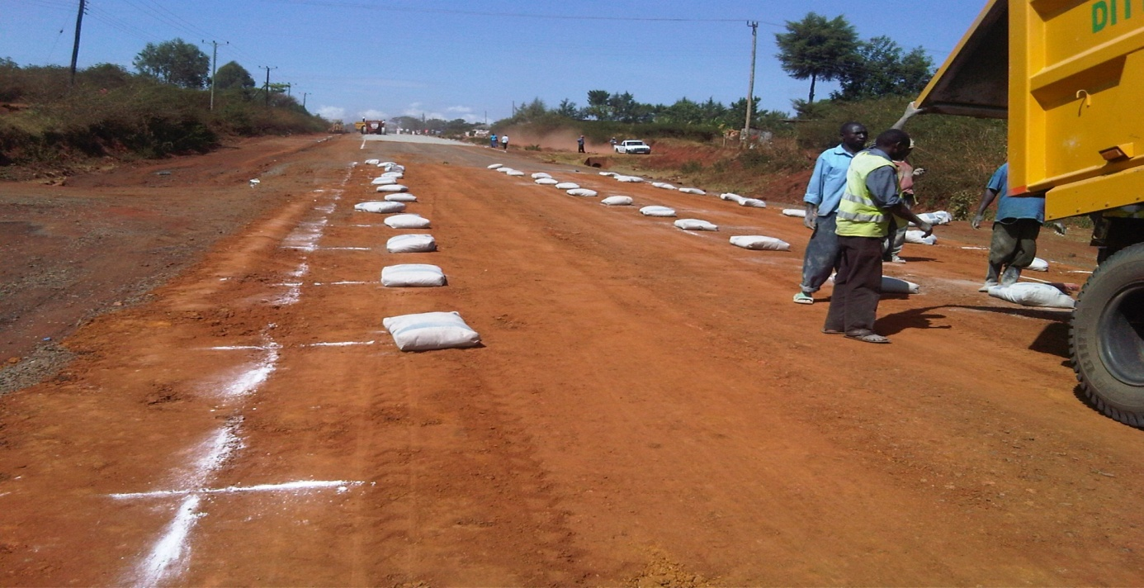
Stabilization at kitale-sibanga

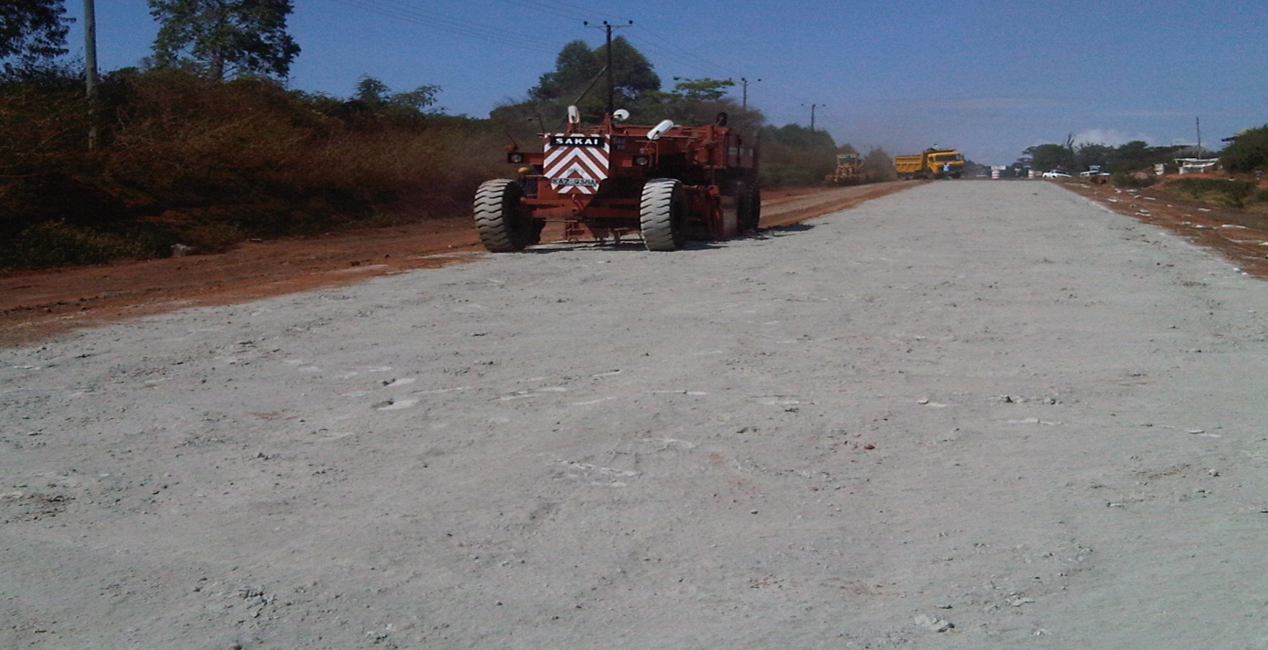
Stabilization Process using Sakai Reclaimer

2.Summary Portfolio
FINANCIAL YR | PROJECT NAME AND COUNTRY | CLIENT | VALUE OF CONTRACT | SCOPE OF WORK | STATUS,  COMPLETION DATE
2005 | Construction of commercial house in Eldoret | Salanic Printers  P.O BOX 8400,Eldoret | 20.5M | Build to Completion | Completed November 2005
2006 | Construction of residential house in Eldoret | Mr.Silas Simatwo  P.O BOX 3811,Eldoret | 19.6M | Build to Completion | Completed November 2006
2007 | Construction of residential Flats at Chaani,Mbs | Simcon Freight Ltd,Mbs  P.O BOX 97166,Mbs | 52.7M | Build to Completion | Completed November 2007
2008 | Proposed lorry parking yard for Simcon Freight Ltd at Mazeras, Mombasa. | Simcon Freight ltd Mombasa, kenya | Full contract  31.78 million | Masonry perimeter wall,1 storey office block,1 line of culverts, drainage work with lining, septic tank. underground water storage tank, elevated water storage tank, bush clearing, construction of pavement with compacted hand packed stones and surfacing with watered and compacted gravel | Completed  May 2008
2009 | Proposed grading and gravelling of Nyaru-Kimwarer road-C 54 | Director General KeRRA, Kenya.  Kilel  0722755517 | Full contract  5.0 million | Grading, gravelling , compaction, culverts installation , ditch and catch water digging  Heavy Bush clearing and installation of score checks, drift installation | Completed  April 2009
FINANCIAL YR | PROJECT NAME AND COUNTRY | CLIENT | VALUE OF CONTRACT | SCOPE OF WORK | STATUS,  COMPLETION DATE
2009 | Construction of Brook-view residential flats at Muthaiga off Murang’a road | Vomorono Ltd. 0721562780 | Full contract 298Million | Building and erection from setting out to completion,access road,parking to gabbro standard,drainage works | Completed November 2009
2010 | Construction of Vomorono offices off Mombasa road | Vomorono Ltd. 0721562780 | Full contract 320 Million | Building and erection from setting out to completion,storm water drain,access road,parking | Completed 2010
2010 | Proposed grading and gravelling of Farfaral -Ziwa Machine-Kerotet | Director General KeRRA, Kenya  Eng. Shachile  0721672619 | Full contract  1.032168 million | Grading, gravelling, culverts installation and cleaning, ditch digging  Heavy Bush clearing | Completed  May 2010
2010 | Proposed Construction of Kapsaos-Kapkoros Ward Office | Eldoret Municipal Council.  Eng.Lutta 0725215065 | Full contract  1.98494 million | Building erection from setting out to completion | Completed  August 2010
2011 | Proposed Spot Improvement Works on Tapsagoi – Moror – Ngenyilel Rd | Director General KeRRA, Kenya  Eng. Shachile  0721672619 | Full contract  26.800400 million  NB.1.5 Million Variation due to change in scope of work | Bridge back filling, gabion installation Grading, gravelling with watering and compaction, culverts installation and cleaning, ditch and catch water digging  Heavy Bush clearing, gabion grouting, installation of score checks ,guard rails installation | Completed February 2011
FINANCIAL YR | PROJECT NAME AND COUNTRY | CLIENT | VALUE OF CONTRACT | SCOPE OF WORK | STATUS,  COMPLETION DATE
2010 | Proposed Construction at Tagore Rd, Eldoret | Eldoret Municipal Council,  Eng.Lutta 0725215065 | Full contract  1.83855 million | Grading, gravelling with watering and compaction, culverts installation and cleaning, ditch and catch water digging  Heavy Bush clearing and installation of score checks, drift installation | COMPLETED  July 2010-sept 2010
2011 | Proposed construction of Sugoi Footbridge | Ministry of Public Works, Eng Wathome 0725215065 | Full contract 6,075,212 | Fabrication of 36m span bridge deck, side cages and anchoring it on RC columns and foundation pads. Construction of approach ramps | COMPLETED Feb 2011-Mar 2011
2011 | Proposed construction of Matiny Development,Kitale | Vomorono Ltd,  P.O BOX 11250,Nrb. | Full contract 313million | Building and erection from setting out to completion, access road, parking to gabbro standard, drainage works | COMPLETED Feb 2011-march 2012
2011 | Proposed construction of Baharini-Daraja mbili road | Director general KeRRA, Kenya. Eng. Sachile 0721672619 | Full contract 2.4million | Grading, gravelling without watering and compaction, Culvert installation and cleaning, ditch catch water digging, Heavy bush clearing and installation of score checks, drift installation. | COMPLETED March 2011-April 2011

FINANCIAL YR | PROJECT NAME AND COUNTRY | CLIENT | VALUE OF CONTRACT | SCOPE OF WORK | STATUS,  COMPLETION DATE
2011/ 2012 | Proposed reinstatement of road wash out at Kamatira | Director General,KeNHA,Kenya. Eng. Amingh | Full contract sh.  39,337,155 million | Bank stabilization,construction of gabion retaining walls interspersed with reinforced concreted framework,mechanical rip rap at tail end of drain channel,construction of box culvert,construction of lined drains on approaches of failed culvert sections. | Ongoing January 2012
2011/ 2012 | Proposed construction of Eldoret- Nyaru road. | Director General,KeNHA,Kenya. Eng. Amingh | Full contract sh.80,755,875 | Heavy patching , Stone Hand packing and Reinstatement of Shoulders to Carriageway | Ongoing January 2012
FINANCIAL YR | PROJECT NAME AND COUNTRY | CLIENT | VALUE OF CONTRACT | SCOPE OF WORK | STATUS,  COMPLETION DATE
2011/ 2012 | Proposed Construction of Ortum box culvert on A1 road | Director General KeNHA, Kenya. Eng. Nyabuto 0721952404 | Full contract 26.96615460 million | Construction of box culvert, road diversion, gabion boxes, stone pitching, river training, Heavy bush clearing and installation of score checks. | ONGOING ,90% Completed.  To February 2012
2011/ 2012 | Proposed construction of Kitale-Sibanga road | Director General KeNHA, Kenya. Eng. Nyabuto 0721952404 | Full contract 159.97874592million | Pot hole patching, shoulder Reconstruction, Reconstruction of Base and Sub-base, Drainage opening, Culverts installation, Re-carpeting with premix asphaltic concrete, traffic control. | ONGOING,80% Completed.  To February 2012
2012/2013 | Proposed construction of Kapsoya Roads | General manager, Design and construction, KURA Kenya.Eng.Nyomboi | Full contract 887,104,562.50 million | Pothole patching, Reconstruction of base and sub-base,Drainage opening, culverts installation,Recarpeting with premix asphaltic concrete,compaction of ground,Grassing,laying of concrete pipes | To commence August 2012

